**Emotions as ways of knowing**

Traditional view claims that emotions can cloud our knowledge and we need to see how we can defend ourselves against their destructive influence. On the other hand, we need to remember that emotions also play a more positive role in our mental life, since without them we would be unable to make sense of the world. And we will take a closer look at the nature of intuition.

So, we will talk about:

**1. Emotions as an obstacle to knowledge**;

**2. Emotions as a source of knowledge**;

**3. Intuition**.

**1. Emotions as an obstacle to knowledge**

Since emotions are integral part of our mental lives, they have an influence on the way we see and think about the world. Strong emotions can sometimes distort the three other ways of knowing:

- **Perception**. Strong emotions can color our perception of things, f. e. ‘love is blind’ – means if you love someone you probably won’t see their faults.

- **Reason**. If you hold your beliefs with too much passion it can prevent you to be open-minded.

- **Language**. A person who has strong emotions will most likely use emotive language.

**Rationalizations**

Sometimes, when we are under influence of strong emotions, we tend not to reason, but to *rationalize* our pre-existing prejudices. For example, if someone is passionate smoker and he is also familiar with the evidences that smoking causes cancer, he may try to rationalize the situation by saying that these evidences are wrong.

Rationalizations can lead a person to develop wrong but self-confirming belief system. Example:

- Henry has an emotional prejudice against immigrants. His prejudice will lead to the following:

1. **Biased perception**. He notices only lazy immigrants and overlooks hard-working ones.

2. **Fallacious reasoning**. He makes hasty generalizations from his own limited experience.

3. **Emotive language**. He concludes that immigrants are ‘bone idle’ and ‘don’t know the meaning of hard work’.

The above factors will just reinforce the original prejudice and make it impossible for Henry to be objective.

**Irrational behavior**

Strong emotions can lead us to make poor decisions. Sometimes when we are influenced by the emotions we say or do things that we later regret.

So, it may seem that the best situation would be to completely abandon our emotions and look at the world in an objective way. A group of ancient philosophers known as the **Stoics** advocated life without emotions, passions. The goal was to reach a state of mind called **apathy**, in which mind can mirror reality while free of pain and troubles caused by the emotions.

**2. Emotions as a source of knowledge**

But, can we even imagine meaningful human life without any emotions? When we say that someone is ‘cold and unemotional’ we don’t mean that they have *no* emotions, but that they have few emotions compared with the average person. Mr. Spock, a character from the Sci-Fi series, *Star Trek*, is well known for his absence of emotions and rational and logical behavior. But if you look closer, Spock is not so much lacking in emotions as *in control* of his emotions.

Spock is actually just controlling his emotions – he is always calm in dangerous situations, he never raises his voice, doesn’t show fear, and so on. But he *must* have been driven by some motives or goals. Something must have driven him to go to explore strange new worlds, seek out new civilizations etc. Possibly, it was intellectual curiosity, a drive to set and solve problems, solidarity with allies – in one word – emotions.

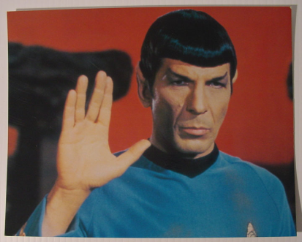

Psychological studies show that without any emotions our life would quickly disintegrate. Emotions help us not to become ‘rational fools’, unable to make decisions in everyday life. Emotions can guide us to make decisions we are unable to make if we rely on reason only.

**The relation between reason and emotion**

It seems that reason and emotion are closely related to one another and it is difficult to make a clear distinction between them. It makes more sense to say that there is a *more-or-less* continuum of mental activity running from the very rational to the very emotional. When you are solving a mathematical problem you are at one end of the continuum, and when you lose your temper you are at the other end, but most of the time you are somewhere in the middle.

Emotion Reason

| | |

Furious Getting annoyed Solving a maths

problem

It also makes more sense to say that reason and emotion are not opposed to one another, but our emotions can be more or less rational. Aristotle said:

‘Anyone can be angry – that is easy. But to be angry with the right person to the right degree, at the right time, for the right purpose and in the right way – that is not easy.’