# Test B Use of English

A Read the text and put the verbs in brackets in the Active or Passive Voice in the correct tense.

|  |  |
| --- | --- |
|  | / 13 |

Curitiba, in southern Brazil, is typical of many developing cities. After 1950, it (0) _____*changed*______ (change) dramatically as its economy, which (1) _______________ (base) on agriculture, (2) _______________ (move) into the industrial stage. As in many other cities, this change (3) _______________ (create) poverty, but Curitiba (4) _______________ (manage) to control the problems that go with it, like crime and lack of education. Other typical urban problems (5) _______________ (avoid) as well. The most striking feature of Curitiba is its transport system. Private cars (6) _______________ (not allow) in the city centre, and the bus network is fast and efficient. Ticket prices (7) _______________ (keep) low so people on low incomes can use the network. Curitiba (8) _______________ (recycle) 70 per cent of its rubbish and the whole population (9) _______________ (involve) in collecting it. The man responsible for Curitiba’s development is the city’s mayor, Jaime Lerner. He says that Curitiba (10) _______________ (succeed) because everyone (11) _______________ (make) responsible for improving the city. To do that, he says, the poor must (12) _______________ (give) good services so they (13) _______________ (share) in improving the quality of life.

(Adapted from *BBC English*)

B There are mistakes in seven out of these ten sentences. Rewrite them correctly.

|  |  |
| --- | --- |
|  | / 10 |

0 My boyfriend, which father is a scientist wants to study mathematics.

*My boyfriend, whose father is a scientist,________________*

*wants to study mathematics.___________________________*

00 He made a few suggestions about how we could spend the money.

*correct____________________________________________*

__________________________________________________

1 Roosevelt that became famous for his military achievements was the 26th president of the US.

__________________________________________________

__________________________________________________

2 I’d like John to come to our party. He tells so funny jokes.

__________________________________________________

__________________________________________________

3 Our biology teacher made a great influence on Tom’s future career.

__________________________________________________

__________________________________________________

4 Many pupils use their mobile phones at school, what is considered unacceptable.

__________________________________________________

__________________________________________________

5 Richard used to be crazy about British rock groups such as The Rolling Stones.

__________________________________________________

__________________________________________________

6 I read an article who discussed the issue of euthanasia in some depth.

__________________________________________________

__________________________________________________

7 He was such unpredictable that Ann decided to break off her engagement.

__________________________________________________

__________________________________________________

8 I got fed up with being criticised by people from other advertising agencies.

__________________________________________________

__________________________________________________

9 There are a lot of teenagers who have a good command of a foreign language.

__________________________________________________

__________________________________________________

10 Fresh evidence suggests that the woman may be forced to commit suicide.

__________________________________________________

__________________________________________________

C Complete the idioms with one appropriate word. Then explain in English the meaning of each idiom.

|  |  |
| --- | --- |
|  | / 9 |

0 She was as sick as a ________*dog*_____________________ .

*She was very ill.____________________________________*

1 It’s a pity he let the cat out of the ______________________ .

_________________________________________________

2 Margaret has always been the black ____________________ .

of the family. ______________________________________

1. I’m not going to join the rat ___________________________ .

_________________________________________________

4 She has a bee in her _____________________ about dancing.

_________________________________________________

5 My Scottish niece, who only speaks English, feels like a fish out of __________ when she goes abroad.

__________________________________________________

6 I wish I could be a fly on the ___________________________ during their meeting.

__________________________________________________

D Complete the text with appropriate words. Use only one word in each gap.

|  |  |
| --- | --- |
|  | / 3 |

Being a boss in a busy transport firm, I am used to making (0) __*it*_ in business, even if it means difficult discussions with my employees. Yet some of these contacts can be rather unpredictable and surprising. For example, last week an employee of mine asked for a pay rise. Although she came (1) _____ as a very intelligent person, I had to (2) _____ down her request because she hadn’t been with the firm long enough. As a rule, I don’t (3) _____ in for talking with people in such situations for long, so she left immediately. By the way, she didn’t appear terribly disappointed. Still, imagine my surprise when next morning she turned (4) _____ an hour early for our regular staff meeting and asked to see me. She entered my office carrying a parcel wrapped (5) _____ in coloured paper. She was all smiles and said, ‘Please accept this thank you gift. Thanks to you, I know now what I really want to do in my life, and I’m sure I’ll (6) _____ to the top one day!’ Inside, there was a book of her poems.

E Complete the sentences with the correct word.

|  |  |
| --- | --- |
|  | / 5 |

0 Mr Smith *made/got* angry the very moment he saw her.

1 My mother voiced her objection to my plan to *pierce/varnish* my ears.

2 Since they were *striding/strolling* across the lawn, I was soon left behind.

3 The *catchy/sinister* plot of the film made everybody scared.

4 I tried taking sleeping pills but they didn’t *make/have* any effect.

5 They didn’t buy anything there because the shop sold *tacky/trendy* souvenirs.

6 We stopped on the way to admire the very *picturesque/attractive* countryside.

7 When Barbara was pregnant, she *went off/ turned off* sweets and sugar.

8 An *enraged/indolent* customer made a complaint to the manager.

9 Why are you *yawning/shrieking*? Are you bored with what I’m saying?

10 Your hairstyle is a bit *tasteless/dated*. It was fashionable many years ago.

|  |  |  |
| --- | --- | --- |
| TOTAL |  | / 40 |

# Test B Writing

Task

Look at the drawing and speculate about the kind of person who could live in this place. Write a description four paragraphs long about the person and the room. Include the following information:

* the room itself (furniture, arrangement and decoration);
* the person’s age;
* the person’s likes and dislikes and how they are reflected in the choice of objects in the room;
* the person’s character and how it is reflected in the room arrangement;
* the person’s moods and ways of spending money in the room.

The description should be 200–250 words. Do not exceed the word limit.

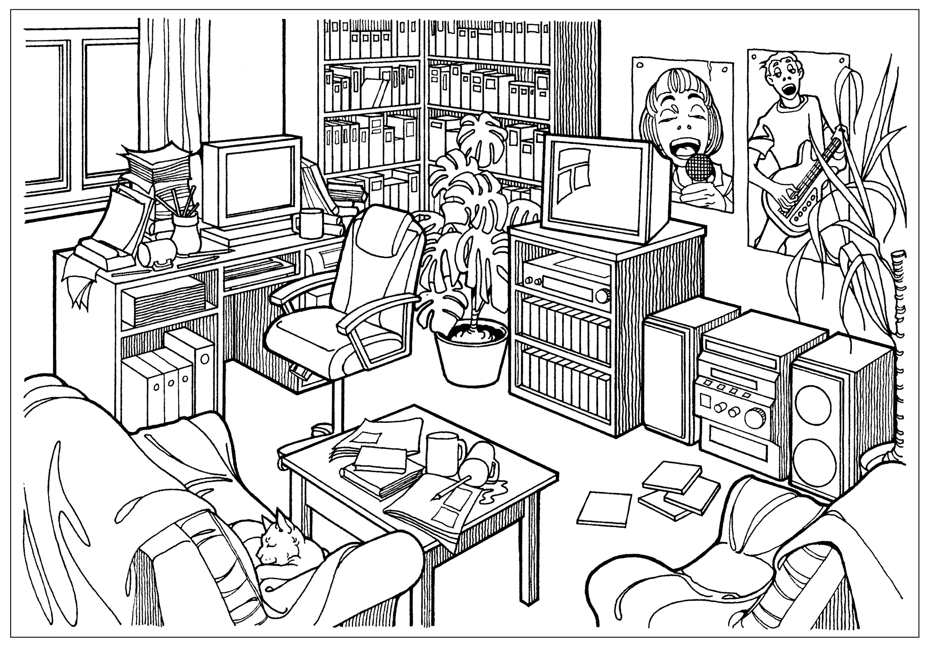

In your description, include:

* *expressions: very, a bit (too), quite, rather, absolutely, much, slightly, fairly, pretty, extremely, totally, completely, really;*
* examples of relative clauses;
* structures with *so* and *such*.

|  |  |  |
| --- | --- | --- |
| TOTAL |  | / 20 |

# Test B Reading

**Welcome to SKIN DEEP** – The art of the tattoo

While its meaning has varied from people to people and from place to place, tattooing has most often served as a sign of social status, as a mark of one’s passage through life, or simply as a way to beautify the body. Tattooing had existed for thousands of years before England’s Captain Cook found it in the South Pacific in 1769, but it was his crew and other merchant and naval seamen like him who soon spread the art to Europe and America.

[1] The close relationship between naval men and tattooing developed quickly after Cook’s voyages to the South Pacific. At first, sailors’ tattoos were drawn by native tattooists; then sailors began to tattoo each other aboard ship. Eventually, professional tattoo shops, many of them established by former sailors, appeared in port cities around the world. The practice became so entrenched among seamen that it is estimated that by the end of the nineteenth century, 90 per cent of all sailors in the United States Navy had tattoos.

[2] By the second half of the nineteenth century, tattoos were still largely viewed as shocking and frightful, the mark of a person exiled from society. Popular magazines of the time printed articles such as ‘The Savage Origin of Tattooing’ that linked tattooing with cannibals, criminals and lunatics. However, by the dawn of the twentieth century, a number of circumstances had arisen that together helped prompt the spread of tattooing. An electric tattooing machine patented in 1891 allowed for easier, faster, and more decorative tattooing. In Europe and America, fascination with the new and unusual grew as restrictive Victorian social norms fell away. It was in this environment that tattoo artists set up shops and made the art of tattooing available to the brave, the curious and the impulsive.

[3] Prejudice often influenced sailors’ choice of tattoo design. Roosters were thought to protect sailors from drowning. The Christian cross tattooed on the feet was thought to guard against shark attack. Yet another superstitious custom held that sailors should be tattooed with the image of a dragon when they crossed the international date line. While tattoo imagery was often superstitious in nature, getting tattooed was also a highly practical decision: it increased the chance of a body being identified if lost overboard.

[4] Just as sailors brought the tattoo to America from exotic ports of call, the circus and side show took the tattoo across the country. Circus and side show performers often wore tattoos as a way of increasing their appeal to audiences and thus improving their earnings. As early as 1884, carnivals, side shows, circuses and travelling fairs were advertising tattooed performers among their acts. During the Depression, some tattoo artists who were unable to support themselves, travelled with circuses and side shows. As the American public lost interest in the carnival side show, many tattoo celebrities joined larger circuses or opened their own tattoo parlours.

[5] During the American Civil War, patriotic themes became very popular. Tattoos commemorating the battle between the Monitor and the Virginia (formerly the Merrimack) and the Alabama and the Kearsarge began appearing on sailors’ chests and backs. Flags and eagles became popular symbols. Tattoos also reflected the navy’s transition from sail to steam.

Once regarded in the West as frightening and unpleasant, the tattoo has enjoyed great popularity in our own culture in recent years. Everywhere we look today – movies, advertisements, television – there are signs that people of all walks of life appreciate and practise the art of the tattoo.

Task 1

Read the article and match the paragraphs (1–5) with the headings (A–E).

|  |  |
| --- | --- |
|  | / 5 |

A The Tattoo in the Circus and Side Show.

B Tattoo: the Mark of the Sailor

C Patriotic Symbols

D The Spread of Tattooing

E The Role of Superstition

Task 2

Read the article again and answer the questions.

|  |  |
| --- | --- |
|  | / 5 |

1 Who were the first people to draw sailors’ tattoos?

2 What happened in 1891?

3 What tattoo was supposed to protect sailors against the attack of sharks?

4 Why did circus and side-show performers wear tattoos?

5 What were the most popular tattoos during the Civil War?

|  |  |  |
| --- | --- | --- |
| TOTAL |  | / 10 |

# Test B Listening

Task

Track 5

Listen to two people giving their opinions about a film they have seen recently. Match each opinion (1–10) with the person who said it. Some opinions were expressed by both people. Tick (✓) your answers in the table below.

|  |  |
| --- | --- |
|  | / 10 |

|  |  |  |  |  |
| --- | --- | --- | --- | --- |
|  |  | Woman | Man | Both |
| 1 | The film has a great story based on a fairy tale I love. |  |  |  |
| 2 | The plot and characters are not surprising enough. |  |  |  |
| 3 | The film would be better if it could be made shorter. |  |  |  |
| 4 | The sound track would appeal to a teenage audience. |  |  |  |
| 5 | The music was too contemporary. |  |  |  |
| 6 | The film is addressed to a female viewer. |  |  |  |
| 7 | Julie Andrews’ and Anne Hathaway’s acting is one of the film’s strengths. |  |  |  |
| 8 | The film shows an ideal imaginary country. |  |  |  |
| 9 | The film could do with a few bad characters. |  |  |  |
| 10 | The film’s drawbacks are compensated for by the fact that it is a comedy. |  |  |  |

|  |  |  |
| --- | --- | --- |
| TOTAL |  | / 10 |

# Test B Speaking

Debate Task

‘Beauty is in the eye of the beholder.’

**You will have a conversation with your examiner. Discuss the aspects of beauty which make it subjective and those which you think are more objective. Your examiner will sometimes contradict you. Try to react to your examiner’s counter-arguments. You have 30 seconds to think over your points.**

|  |  |
| --- | --- |
| Here are some arguments you may wish to include: |  |
| For | Against |
| * Appreciation of beauty is a matter of individual taste. | * There are classical definitions of beauty which might be seen in someone’s face or the symmetry of a building. |
| * It isn’t possible to force someone else to see beauty in something. | * Some things are just plain ugly. |
| * A person creates an individual concept of beauty through his/her own experiences. | * Today what is beautiful is too influenced by changing fashions and political correctness. |
| * Opinions about what is beautiful are often instinctive and intuitive and not always easy to express. | * What is considered beautiful today should still be thought beautiful in 100 years’ time. |

|  |  |  |
| --- | --- | --- |
| TOTAL |  | / 20 |