Name: DATE: 14/09/2016

**ANIMAL CELL**

Direction:

Place the correct letter in the data table (below the picture) to indicate the correct organelle. Also, describe the function of each organelle in the cell.

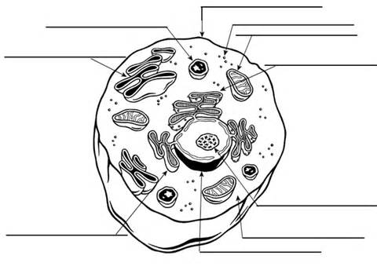

|  |  |  |
| --- | --- | --- |
| ORGANELLE | **DIAGRAM LOCATION (LETTER)** | **FUNCTION** |
| Cell (plasma)membrane |  |  |
| Ribosomes |  |  |
| Cytoplasm |  |  |
| Golgi complex |  |  |
| Lysosome |  |  |
| Mitochondria |  |  |
| Nucleus |  |  |
| Endoplasmic reticulum |  |  |
| DNA material |  |  |

1. List differences between animal and plant cells.
2. Describe the structure of bacterial cell.